Charter Oak State College  Alumni Association  Survey | 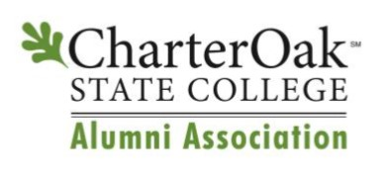
Did You Know – Every graduate of Charter Oak is valuable to our College!

The Alumni Association can accomplish nothing without the engagement of former COSC students. Please take a moment to respond to the survey below and return to alumni@charteroak.edu or the address listed below.

Did You Know – Alumni Support is Greatly Appreciated!

Please mark the Volunteer and Committee Opportunities you’d like to learn more about:
☐ Ambassador | ☐ Graduation | ☐ Board Membership
☐ Career Development | ☐ Career Mentoring | ☐ Community Service
☐ Scholarship | ☐ Fundraising | Other: ______________________
☐ Phone-a-thon | ☐ Workshops

Did You Know – There are over 15,000 Charter Oak Graduates!

Please help us by selecting which Social Activities you’d be interested in:
☐ Dinner & Show | ☐ Happy Hour | ☐ Sporting Events (viewing)
☐ Golf | ☐ Bowling | ☐ Community Service Volunteer
☐ Alum Led Workshops | ☐ Bus Trip | 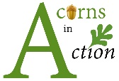
☐ Social / Networking

Did You Know – We would like to Keep in Touch with YOU!

Tell us how you like to receive updates:
☐ Email ☐ Mail ☐ Phone ☐ Text ☐ Newsletter ☐ Website
☐ Social Media: Facebook ☐ LinkedIn ☐ Twitter ☐
☐ All of the Above Other: _____________________________

Please provide your Current Contact Information:
First & Last Name
Street Address
City, ST & ZIP Code
Degree Conferred: ☐ Associate ☐ Bachelor’s ☐ Master’s
Phone
E-Mail (Preferred)
Employer / Title
Field/Industry
☐ Acorns in Action Become a Community Service Volunteer!
☐ Ambassador Receive your official Alumni Ambassador pin!!

Did You Know – We Value Your Input!

Comments appreciated:

____________________________________________________________________________________
Charter Oak State College | 55 Paul J. Manafort Sr. Drive, New Britain, CT 06053 | 860-515-3889 | alumni@charteroak.edu

